**Evidence for Analysis and Design Unit.**

Name: Heather Rae

Cohort: 15

Date here: 2017

**AD - 1 Use case Diagram**

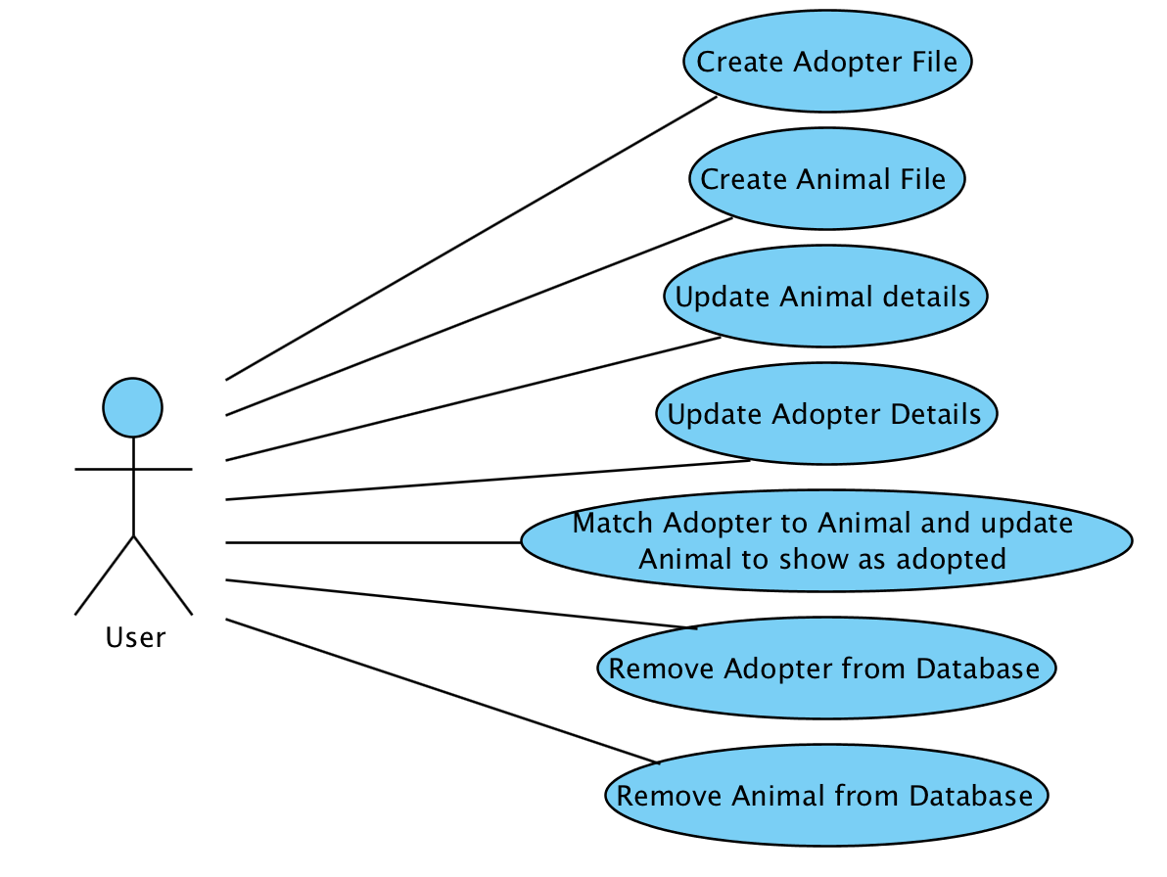

**AD - 2 Create a Class diagram using your Use case diagram.**

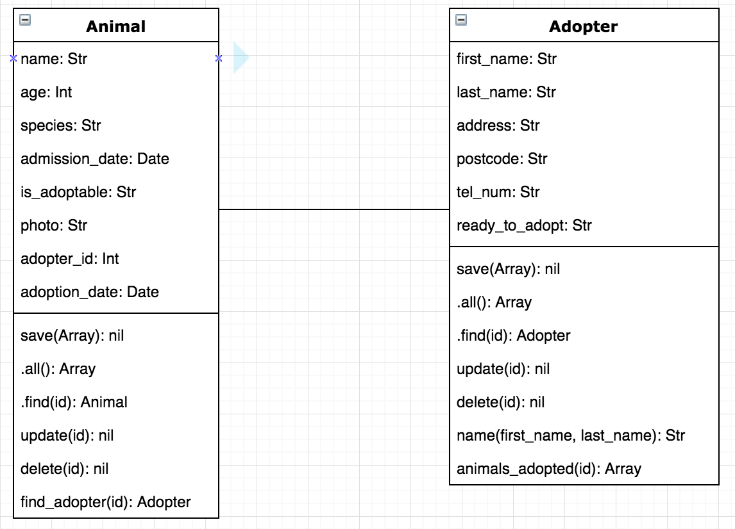

**AD - 3 Object diagram**

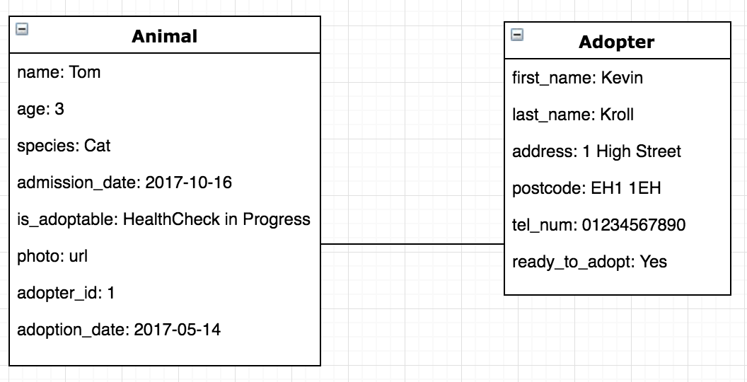

**AD - 4 Activity diagram**

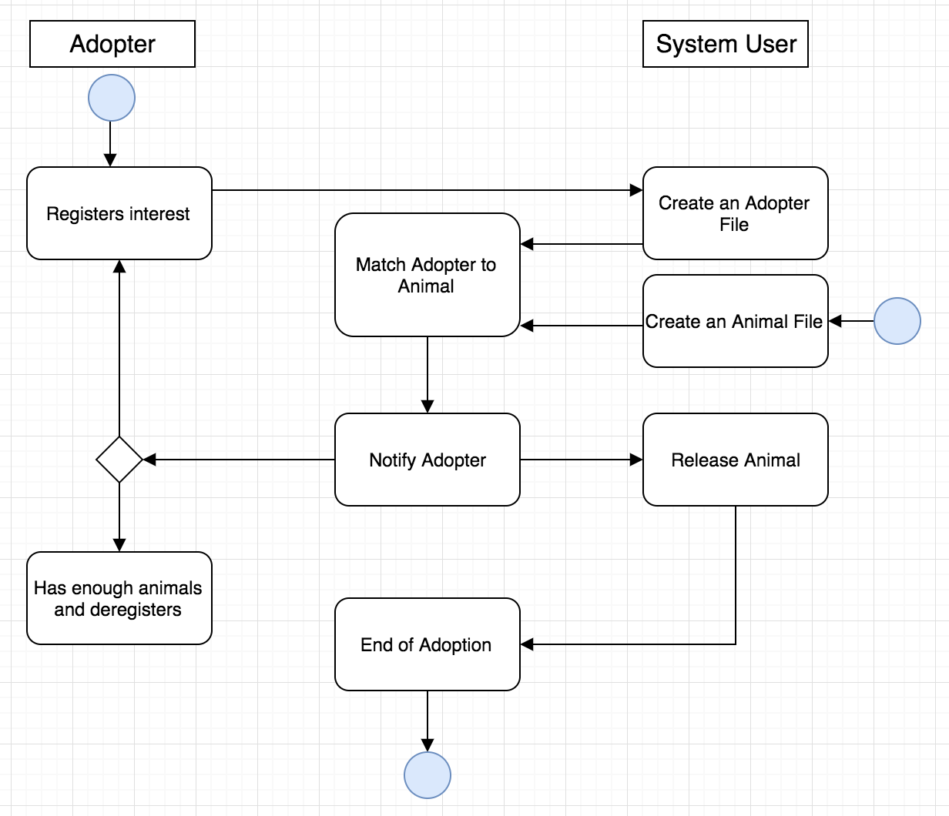

**AD - 5 Inheritance diagram**

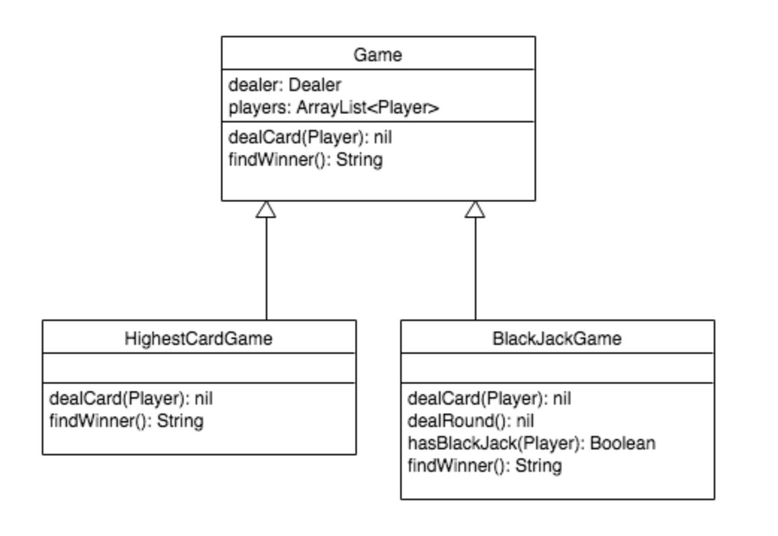

**AD - 6 Implementations Constraints**

|  |  |  |
| --- | --- | --- |
| **Constraints** | **Possible effect of constraint** | **Solution** |
| **Hardware and software platforms** | **Not all pages of the website can be viewed on a mobile device. As not all users will have access to a desktop device they will be unable to view the site at it’s optimum and may be unable to use it.** | **Make better use of flexbox to ensure site is responsive and can be viewed on screens of varying dimensions.** |
| **Performance requirements** | **When uploading photos, all photos must be stored in a specified directory. If the user is not aware of where this directory is located then they will be unable to upload images. Inability to upload photos may cause user to leave information incomplete or use a competitor site.** | **By asking the user to type in a full address for the image this may allow a photo from elsewhere to be uploaded. Alternatively, as there will only be one user(Animal Shelter staff) they will be aware of where the images must be stored to allow the program to find them.** |
| **Persistent storage and transactions** | **As this project uses the local machine to host the server, should this machine be damaged, corrupted the data will be lost. This will cause the user to lose information and does not create an excellent user experience.** | **Would have to consider using an external server to ensure protection of data.** |
| **Usability** | **When marking an animal as adopted, the dropdown option to add the adopter name does not appear until the user has updated the animal and then gone back into the update screen again. Clients may be unaware this can be added and therefore will leave the information out. This will mean that adoptions can then not be detailed on the site and makes the product not fit for purpose.** | **Given more time, a solution to this may have been found to make the adoption function more user friendly. Ideally, adoption name and date would be added at the same time as updating the animal to “Successfully adopted”.** |
| **Budgets** | **There was no budget for this project** | **N/A** |
| **Time** | **The time permitted for the project was one week.** | **Given more time further functionality and design could have been implemented.** |